# Spiral Matrix

Given an m x n matrix, return *all elements of the* matrix *in spiral order*.

**Example 1:**

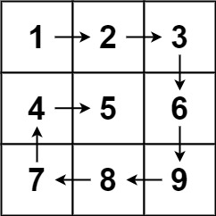

**Input:** matrix = [[1,2,3],[4,5,6],[7,8,9]]

**Output:** [1,2,3,6,9,8,7,4,5]

**Example 2:**

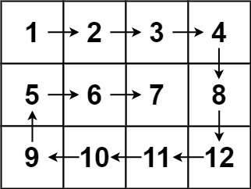

**Input:** matrix = [[1,2,3,4],[5,6,7,8],[9,10,11,12]]

**Output:** [1,2,3,4,8,12,11,10,9,5,6,7]

**Constraints:**

* m == matrix.length
* n == matrix[i].length
* 1 <= m, n <= 10
* -100 <= matrix[i][j] <= 100

Logic:

* Take minrow, mincol, maxrow, maxcol
* Keep track of total number of elements
* Print the outer wall first. For clockwise spiral, print top wall-> right wall->bottom wall->left wall.
* Decrease/increase maxrow,maxcol/minrow,mincol depending on the walls

#include <iostream>

#include <iomanip>

#include <vector>

using namespace *std*;

void display2DMatrix(*vector*<*vector*<int>>& matrix)

{

for (auto i : matrix)

{

for (auto j : i)

{

*cout* << *setw*(2) << j << " ";

}

*cout* << *endl*;

}

*cout* << *endl*;

}

void displayVector(const *vector*<int>& i)

{

for (auto j : i)

{

*cout* << j << " ";

}

*cout* << *endl*;

}

*vector*<int> spiralOrder(*vector*<*vector*<int>>& matrix) {

*vector*<int> spiralMatrix;

int minr = 0; int minc = 0;

int maxr = matrix.*size*() - 1; int maxc = matrix[0].*size*() -1;

int totalElements = matrix.*size*() * matrix[0].*size*();

int count = 0;

while (count < totalElements)

{

// TOP wall

for (auto i = minr, j = minc; j <= maxc && count < totalElements; j++)

{

spiralMatrix.*push_back*(matrix[i][j]);

count++;

}

minr++;

// Right wall

for (auto i = minr, j = maxc; i <= maxr && count < totalElements; i++)

{

spiralMatrix.*push_back*(matrix[i][j]);

count++;

}

maxc--;

// Bottom wall

for (auto i = maxr, j = maxc; j >= minc && count < totalElements; j--)

{

spiralMatrix.*push_back*(matrix[i][j]);

count++;

}

maxr--;

// Left wall

for (auto i = maxr, j = minc; i >= minr && count < totalElements; i--)

{

spiralMatrix.*push_back*(matrix[i][j]);

count++;

}

minc++;

}

return spiralMatrix;

}

int main(void)

{

//vector<vector<int>> matrix{ {1, 2, 3},{4, 5, 6},{7, 8, 9} };

*vector*<*vector*<int>> matrix{ {1, 2, 3, 4}, {5, 6, 7, 8}, {9, 10, 11, 12} };

*vector*<int> vec = spiralOrder(matrix);

displayVector(vec);

return 0;

}